* EXCEPTIONS

**Ex. No. : 11.1 Date: 1/6/2024**

**Register No: 231501051 Name: GOKUL PRASATH P**

Write a Python program that performs division and modulo operations on two numbers provided by the user. Handle division by zero and non-numeric inputs.

Input Format:

Two lines of input, each containing a number. Output Format:

Print the result of division and modulo operation, or an error message if an exception occurs. For example:

|  |  |
| --- | --- |
| **Input** | **Result** |
| 10  2 | 5.0 |
| 10  0 | Error: Cannot divide or modulo by zero. |
| ten 5 | Error: Non-numeric input provided. |

PROGRAM:

try:

a = int(input())

b = int(input())

print(f'Division result: {a/b}\nModulo result: {a%b}') except ZeroDivisionError:

print('Error: Cannot divide or modulo by zero.') except ValueError:

print('Error: Non-numeric input provided.')

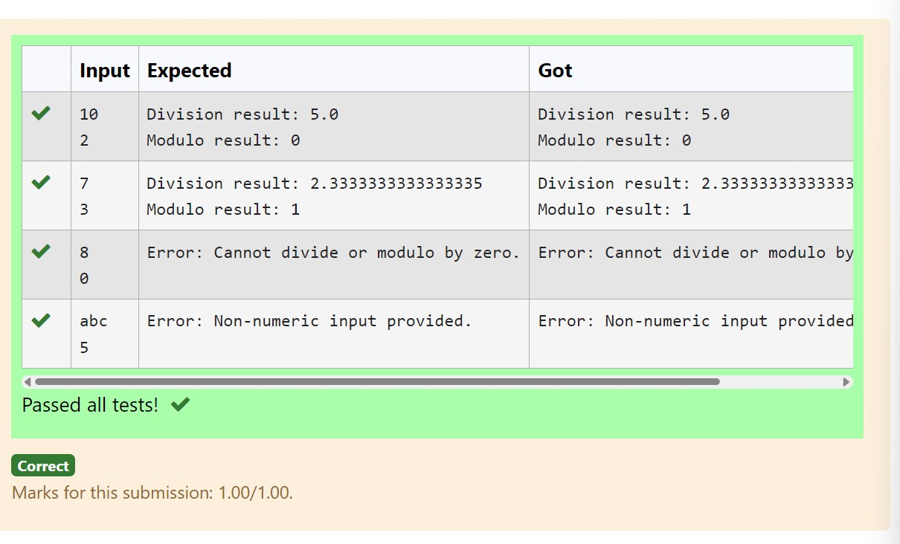

**Ex. No. : 11.2 Date: 1/6/2024**

**Register No: 231501051 Name: HARISH KUMAR**

**V**

Write a Python script that asks the user to enter a number within a specified range (e.g., 1 to 100). Handle exceptions for invalid inputs and out-of-range numbers.

Input Format:

User inputs a number.

Output Format:

Confirm the input or print an error message if it's invalid or out of range. For example:

|  |  |
| --- | --- |
| **Input** | **Result** |
| 1 | Valid input. |
| 101 | Error: Number out of allowed range |
| rec | Error: invalid literal for int() |

PROGRAM:

try:

user_input = int(input("")) if 1 <= user_input <= 100: print("Valid input.")

else:

print("Error: Number out of allowed range") except ValueError:

print("Error: invalid literal for int()")

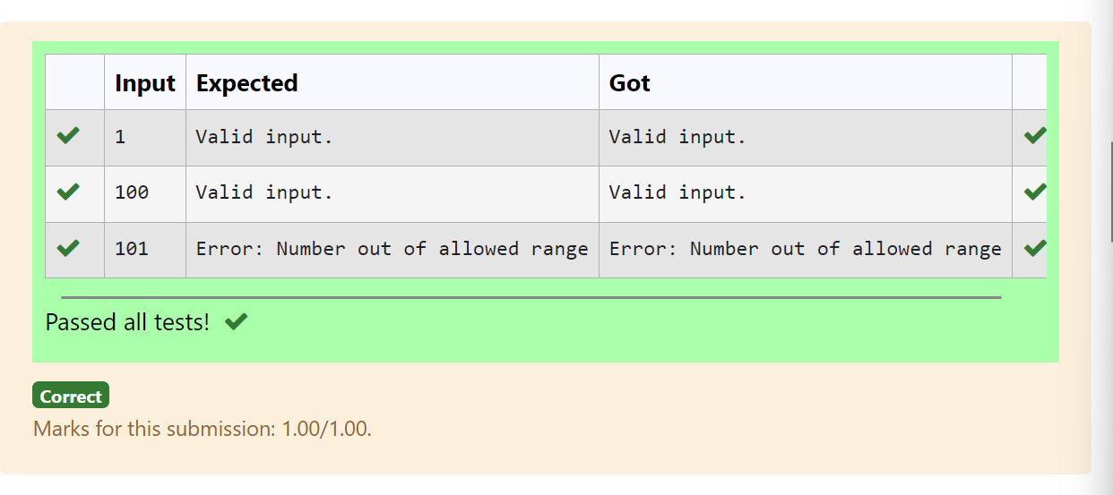

**Ex. No. : 11.3 Date: 1/6/2024**

**Register No: 231501051 Name: HARISH KUMAR**

Develop a Python program that safely performs division between two numbers provided by the user. Handle exceptions like division by zero and non-numeric inputs.

**Input Format:** Two lines of input, each containing a number.

**Output Format:** Print the result of the division or an error message if an exception occurs. For example:

**For example:**

|  |  |
| --- | --- |
| **Input** | **Result** |
| 10  2 | Division result: 5.0  Modulo result: 0 |
| 7  3 | Division result: 2.3333333333333335  Modulo result: 1 |
| 8  0 | Error: Cannot divide or modulo by zero. |

PROGRAM:

while True: try:

num1 = float(input("")) num2 = float(input(""))

result = num1 / num2 print(f"{result}") break

except ValueError:

print("Error: Non-numeric input provided.") break

except ZeroDivisionError:

print("Error: Cannot divide or modulo by zero.") break

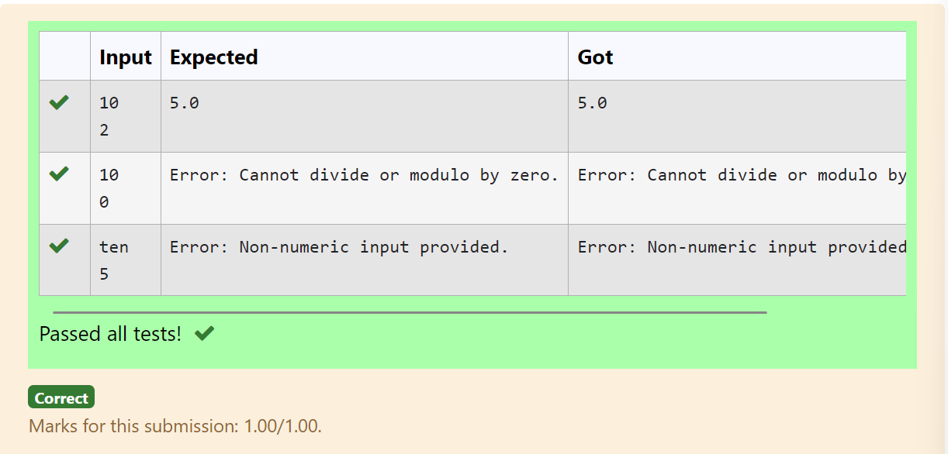

**Ex. No. : 11.4 Date: 1/6/2024**

**Register No: 231501051 Name: GOKUL PRASATH P**

Write a Python program that asks the user for their age and prints a message based on the age. Ensure that the program handles cases where the input is not a valid integer.

**Input Format:** A single line input representing the user's age.

**Output Format:** Print a message based on the age or an error if the input is invalid.

For example:

|  |  |
| --- | --- |
| **Input** | **Result** |
| twenty | Error: Please enter a valid age. |
| 25 | You are 25 years old. |
| -1 | Error: Please enter a valid age. |

PROGRAM:

try:

a = int(input()) if a<0:

print('Error: Please enter a valid age.') else:

print(f'You are {a} years old.')

except (ValueError, EOFError): print('Error: Please enter a valid age.')

OUTPUT:

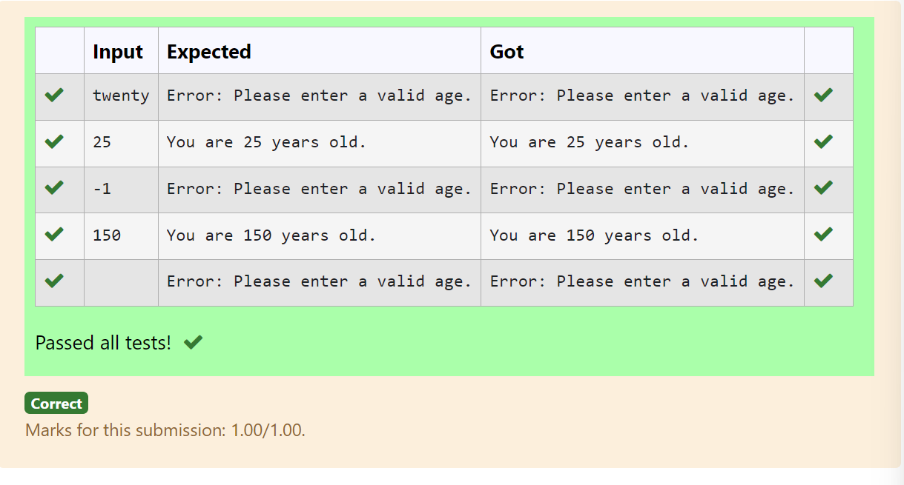

**Ex. No. : 11.5 Date: 1/6/2024**

**Register No: 231501051 Name: GOKUL PRASATH P**

Develop a Python program that safely calculates the square root of a number provided by the user. Handle exceptions for negative inputs and non-numeric inputs.

Input Format:

User inputs a number.

Output Format:

Print the square root of the number or an error message if an exception occurs. For example:

|  |  |
| --- | --- |
| **Input** | **Result** |
| 16 | The square root of 16.0 is 4.00 |
| -4 | Error: Cannot calculate the square root of a negative number. |
| rec | Error: could not convert string to float |

PROGRAM:

import math

while True: try:

user_input = float(input("")) if user_input < 0:

print("Error: Cannot calculate the square root of a negative number.") else:

square_root = math.sqrt(user_input)

print(f"The square root of {user_input} is {square_root:.2f}") break

except ValueError:

print("Error: could not convert string to float") break

OJUTPUT:

